A

Semester Project-I Report

On

“Admission Process System”

In partial fulfillment of requirements for the degree of

Bachelor of Technology

In

## Computer Science & Engineering (Data Science)

### Submitted By

**1. Paliwal Ram Girish**

**2. Sangore Lalit Gulab**

**3.Patil Piyush Rajendra**

**4. Badgujar Yash Satish**

## Under the Guidance of

Prof. A. D. Mairale



**The Shirpur Education Society’s**

**R. C. Patel Institute of Technology, Shirpur - 425405.**

**[2021-22]**



**The Shirpur Education Society’s**

**R. C. Patel Institute of Technology**

**Shirpur, Dist. Dhule (M.S.)**

**Department of Computer Science & Engineering (Data Science)**

**CERTIFICATE**

This is to certify that the Semester Project-I entitled “**Admission Process System”** has been carried out by team:

**1. Paliwal Ram Girish**

**2. Sangore Lalit Gulab**

**3. Patil Piyush Rajendra**

**4. Badgujar Yash Satish**

under the guidance of **Prof.** **Atul D. Mairale** in partial fulfillment of the requirement for the degree of Bachelor of Technology in Computer Science & Engineering (Data Science) (Semester-III) of R. C. Patel institute of technology, shirpur during the academic year 2021-22.

**Date: 02-02-2022**

**Place: Shirpur**

**Guide Semester Project-I Coordinator**

**Prof. A. D. Mairale Prof. S. S. Sonawane**

**H.O.D. Director**

**Prof. Dr. Nitin N. Patil Prof. Dr. J. B. Patil**

**ACKNOWLEDGEMENT**

It is our privilege to express our sincerest regards to our Project Guide Prof. A.D. Mairale Sir and Prof. S.S. Sonawane Sir for their valuable inputs, adorable guidance, encouragement, whole-hearted co-operation and constructive criticism throughout the duration of our project.

We deeply express our sincere thanks to our Head of Department Prof. Dr. Nitin N. Patil sir for encouraging and allowing us to present the project on the topic “Line Follower Robot “at our department premises for the partial fulfillment of the requirements leading to the award of B-Tech degree.

We are also grateful to honorable Principal Prof. Dr. J. B. Patil, for his kind support and guidance. Last but not the least I express my sincere thanks to all of my friends who have patiently extended all sorts of help for accomplishing this undertaking, Thank for your kind support.

**Project Team:**

**1. Paliwal Ram Girish**

**2. Sangore Lalit Gulab**

**3. Patil Piyush Rajendra**

**4. Badgujar Yash Satish**

**Contents Page No.**

**1. INTRODUCTION** …06

1.1 Scope

1.2 Resources

1**.3 Perspective**

**2. SOFTWARE AND HARDWERE REQUIREMENT** …09

2.1 Hardware Requirement.

2.2 Software Requirement.

**3. Implementation** …10

3.1 Algorithm .

## **3.2 The Code Given Below Is For to know more information about collage.**

**3.3 The Code Given Below Is for collage admission process.**

## **3.5 Complete Source Code.**

**3.6 Output.**

**4. Conclusion …16**

**5. Reference / Bibliography …17**

**ABSTRACT**

Today all the work at the time of admission of the students is done manually by ink and paper, which is very slow and consuming much efforts and time. It is required to Design of a Computerized Automated Student Admission System, to speed up and make it easy to use system. Student admissions are a vital part of any university’s running because students are what keep a University alive. The student admission is one of the most important activities within a university as one cannot survive without students. A poor admissions system can mean fewer students being admitted into a university because of mistakes or an overly slow response time. The process begins with a potential student completing an application form through the Universities and Colleges Admissions Service, the first step for students is to apply directly to the university through a custom online form. This project’s aim is to automate the system, prechecking the inclusion of all required material and automatically ranking each student’s application based on a number of criteria. These criteria include the ranking of their university, their grade at said university and their language grade Certificate. The data used by the system is stored in a database that will be the center of all information held about students and the base for the remainder of the process after the initial application has been made. This enables things to be simplified and considerably quickened, making the jobs of the people involved easier. It supports the current process but centralizes it and makes it possible for decisions to be made earlier and easier way.

1. **INTRODUCTION**

The name of our college project is Admission Process system. This project is console based, which means in this project we are not using GUI (Graphic User Interface). We can say that it is a console-based website, because in this project we are giving so many options or facilities to users which he/she gets on websites. We have programmed this project in python language, because it is a platform independent and also very easy to use. In Python there are so many powerful libraries which have helped us to make good project.  
In our project we have used libraries named numpy, pandas, matplotlib, web browsers etc.  
NumPy can be used to perform a wide variety of mathematical operations on arrays. It adds powerful data structures to Python that guarantee efficient calculations with arrays and matrices and it supplies an enormous library of high-level mathematical functions that operate on these arrays and matrices. Pandas can be used to import different files (like csv, excel, word) from our device and also to make dataframe by using list and dictionaries in python, we can also query data Frame with help of pandas. Matplotlib is a plotting library for the Python programming language and its numerical mathematics extension NumPy. It provides an object-oriented API for embedding plots into applications using general-purpose GUI toolkits like Tkinter, wxPython, Qt, or GTK. The webbrowser module provides a high-level interface to allow displaying web-based documents to users. Under most circumstances, simply calling the open () function from this module will do the right thing. After running our program, users will see the logo of our college (RCPIT) and the main menu in which  
we have given so many options(choices) to users like he/she may check about Admission section of our college, he/she may get the College address from there, they can also see placement record of our college. Etc.  
In each choices there are sub choices which will help students to understand our college facilities and our program is user friendly because of which user can go back to the main menu whenever he/she wants or user can exit program any time and also the code will keep running until we stop it because of our infinite loop.

Online Admission System is aimed at developing an online admission application for a college. This system is an online system that can be accessed throughout the organization

Online admission system and outside as well with proper login provided. Our system has two type of accessing modes, administrator and user. Student management system is managed by an administrator. It is the job of the administrator to admit and monitor the whole process. When a user log in to the system. He would only view details of the student. He can't perform any changes .The system has two modules. They are

User Administrator Students logging is to apply for the course by filling an application form provided by online. College principal/administrator logging in may also access/search information put up by the students.

**1.1 Scope :**

An organized and systematic office solution is essential for all universities and organizations. There are many departments of administration for the maintenance of college information and student databases in any institution. All these departments provide various records regarding students. Most of these track records need to maintain information about the students. This information could be the general details like student name, address, performance, attendance etc or specific information related to departments like collection of data.

All the modules in college administration are interdependent. They are maintained manually. So they need to be automated and centralized as, Information from one module will be needed by other modules. For example when a student needs his course completion certificate it needs to check many details about the student like his name, reg number, year of study, exams he attended and many other details. So it needs to contact all the modules that are office, department and examination and result of students.

With that in mind, we overhauled the existing Student Database Management System and made necessary improvement to streamline the processes. Administrators using the system will find that the process of recording and retrieving students information and managing their classes, including marking of attendance, is now a breeze. In general, this project aims to enhance efficiency and at the same time maintain information accurateness. Later in this report, features and improvement that allow achievement to this goal will be demonstrated and highlighted.

**1.2 Resources :**

Systems Development Life Cycle (SDLC) is the most common process adopted to develop a project and not surprisingly, this project is following this model too. To be precise, waterfall model is being applied. Waterfall model is a sequential model process where the input of a phase actually results from the previous phase.

There are five phases in this model and the first phase is the planning stage. The planning stage determines the objectives of the project and whether the project should be given the green light to proceed. This is where the proposal submission comes into picture. After obtaining the approval, the next phase is analysis. Gathering and analysing the system and user requirements is essential for entry to the design step.

**1.3 Perspective:**

As the strength of the students is increasing at a tremendous speed, manual maintenance of student admission is very difficult. Hence, the need for online admission is inevitable. In case of manual system they need a lot of time, manpower etc.Here almost all work is computerized. So the accuracy is maintained. Maintaining backup is very easy. It can do with in a few minutes.

**2. SOFTWARE AND HARDWERE REQUIREMENT**

**2.1 Hardware Requirement :**

System : x86 64-bit CPU ( Intel / AMD architecture)

Ram : 4 GB

Hard Disk : 500 GB

**2.2 Software Requirement :**

Operating System : Windows 7/8/10.

Coding Language : Python 3

IDE : Visual Studio Code

**4. IMPLEMENTATION**

* **Work Carried Out:**

By Surveying we find out that student face a problem while searching the college or while filling a form so we programed a simple and user friendly system from which student can conclude easily and also get an idea of form filling.

Imported libraries:

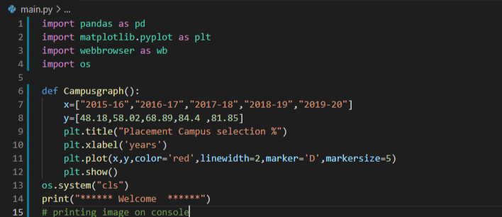

**In the above code we imported libraries like pandas for creating a data frame, matplotlib for displaying campus selection graph as we named campus graph.**

**We stored campus selection information manually by hardcore, also we can use a concept of file handling for future use.**

**We also imported os that is operating system to get a clear screen after implementation.**

. 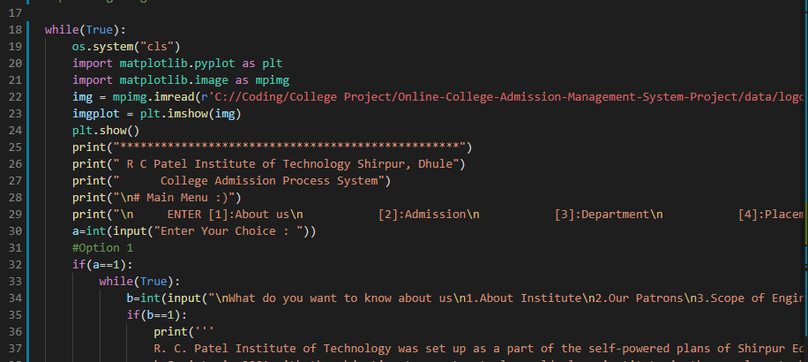

**In the above code we had used while(true) loop. We had called ‘imread()’ function and passed the path of image in this function to display the image. And ‘imread()’ function is part of matplotlib library. Then by using plt.imshow() function we display image. Using print function we had display main menu.**

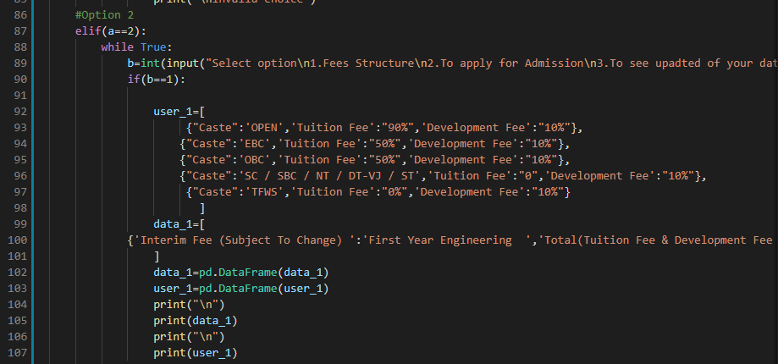

**In the above code we had created two data frames named ‘data_1’ and ‘user_1’ using pandas libraries. Then we use print statement to print both the data frames.**

|  |  |
| --- | --- |
|  |  |

## **Here with the use of print function we had print list of departments which available in our college.**

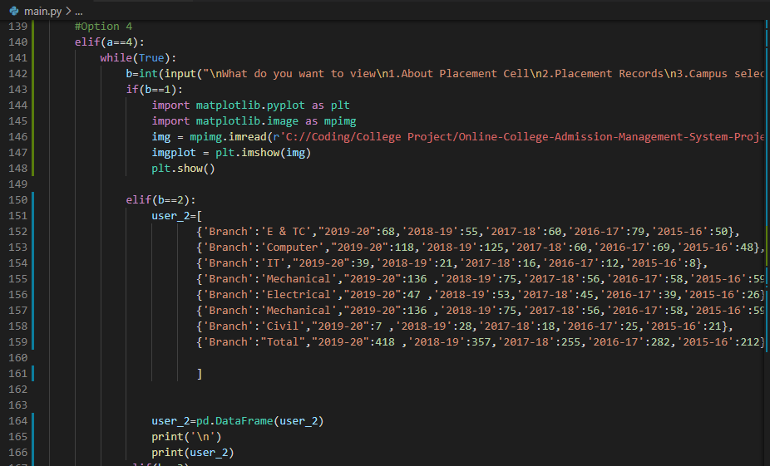

The above code is belongs from placement cell. In while loop we had print some choices a

we ask user to enter his choice then after entering user choice it will store in variable b. if user enter second choice then program will display program co-ordinators image.

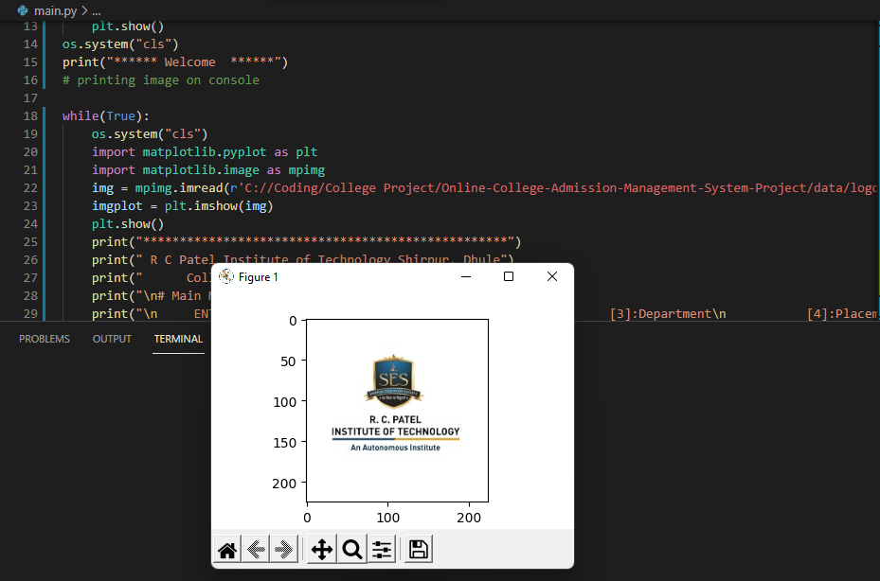 **In the output first we get logo of our institute .**

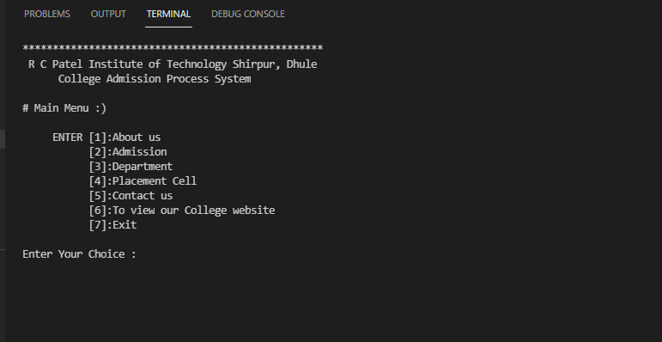

## **After getting logo we gave seven options to the user in the about us there is info about college and in second option of admission admission and admission form will appear. In fourth option placement cell graph will display with the help of data frame. And after pressing last one option program will take to the college website.**

* **Complete Source Code:**

import pandas as pd

import matplotlib.pyplot as plt

import webbrowser as wb

import numpy as np

def Campusgraph():

x=["2015-16","2016-17","2017-18","2018-19","2019-20"]

y=[48.18,58.02,68.89,84.4 ,81.85]

plt.title("Placement Campus selection %")

plt.xlabel('years')

plt.plot(x,y,color='red',linewidth=2,marker='D',markersize=5)

plt.show()

print("****** Welcome ******")

# printing image on console

import matplotlib.pyplot as plt

import matplotlib.image as mpimg

img = mpimg.imread(r'C://Coding/College Project/Online-College-Admission-Management-System-Project/data/logo.jpg')

imgplot = plt.imshow(img)

plt.show()

while(True):

print("\nMain Menu")

a=int(input("\nPress\n1.About us\n2.Admission\n3.Department\n4.Placement Cell\n5.Contact us\n6.To view our College website\n7.Exit\n"))

#Option 1

if(a==1):

while(True):

b=int(input("\nWhat do you want to know about us\n1.About Institute\n2.Our Patrons\n3.Scope of Engineering\n4.Approvals and Affilations\n5.Return to Menu\n"))

if(b==1):

print(''' #Whole text info about institute ''')

elif(b==2):

wb.open("https://www.rcpit.ac.in/our-patrons")

elif(b==3):

print(''' #space for information of department''')

elif(b==4):

wb.open("https://www.rcpit.ac.in/approvals-and-affiliation")

elif(b==5):

break

else:

print('\ninvalid choice')

#Option 2

elif(a==2):

while True:

b=int(input("Select option\n1.Fees Structure\n2.To apply for Admission\n3.To see upadted of your data\n4.Return to main menu"))

if(b==1):

user_1=[

{"Caste":'OPEN','Tuition Fee':"90%",'Development Fee':"10%"},

{"Caste":'EBC','Tuition Fee':"50%",'Development Fee':"10%"},

{"Caste":'OBC','Tuition Fee':"50%",'Development Fee':"10%"},

{"Caste":'SC / SBC / NT / DT-VJ / ST','Tuition Fee':"0",'Development Fee':"10%"},

{"Caste":'TFWS','Tuition Fee':"0%",'Development Fee':"10%"}

]

data_1=[

{'Interim Fee (Subject To Change) ':'First Year Engineering ','Total(Tuition Fee & Development Fee )':"115000/-"}

]

data_1=pd.DataFrame(data_1)

user_1=pd.DataFrame(user_1)

print("\n")

print(data_1)

print("\n")

print(user_1)

elif(b==2):

data=pd.read_csv(r"C://Coding/College Project/Online-College-Admission-Management-System-Project/data/addmission Students 1.csv")

user=data.append({"Name OF Student":input("Enter name"),'Category':input("Category"),'SSC':input("Enter SSc score")

,'HSC':input("Enter HSc marks"),'CET Percentile':input("CET Percentile")

,'JEE Percentile':input('JEE Percentile'),'Preferred Branch 1st':input('Preferred Branch 1st')

,'Prefererred Branch 2nd':input("Prefererred Branch 2nd"),'Phone No':input('Phone No'),

'Address':input("Address")},ignore_index=True)

elif(b==3):

print('\n')

print(user)

elif(b==4):

break

else:

print('\n')

print("\nInvalid choice")

#Option 3

elif(a==3):

print('''\n

DEPARTMENTS

1.Computer Engineering

2.Electronics & Telecommunication Engineering

3.Mechanical Engineering

4.Electrical Engineering

5.Civil Engineering

6.Computer Science & Engineering ( Data Science )

7.Artificial Intelligence and Machine Learning

8.Applied Sciences & Humanities

9.Research Center

''')

#Option 4

elif(a==4):

while(True):

b=int(input("\nWhat do you want to view\n1.About Placement Cell\n2.Placement Records\n3.Campus selection %\n4.Industry Association\n5.Return to Menu\n"))

if(b==1):

import matplotlib.pyplot as plt

import matplotlib.image as mpimg

img = mpimg.imread(r'C://Coding/College Project/Online-College-Admission-Management-System-Project/data/placement.jpg')

imgplot = plt.imshow(img)

plt.show()

elif(b==2):

user_2=[

{'Branch':'E & TC',"2019-20":68,'2018-19':55,'2017-18':60,'2016-17':79,'2015-16':50},

{'Branch':'Computer',"2019-20":118,'2018-19':125,'2017-18':60,'2016-17':69,'2015-16':48},

{'Branch':'IT',"2019-20":39,'2018-19':21,'2017-18':16,'2016-17':12,'2015-16':8},

{'Branch':'Mechanical',"2019-20":136 ,'2018-19':75,'2017-18':56,'2016-17':58,'2015-16':59},

{'Branch':'Electrical',"2019-20":47 ,'2018-19':53,'2017-18':45,'2016-17':39,'2015-16':26},

{'Branch':'Mechanical',"2019-20":136 ,'2018-19':75,'2017-18':56,'2016-17':58,'2015-16':59},

{'Branch':'Civil',"2019-20":7 ,'2018-19':28,'2017-18':18,'2016-17':25,'2015-16':21},

{'Branch':"Total","2019-20":418 ,'2018-19':357,'2017-18':255,'2016-17':282,'2015-16':212}

]

user_2=pd.DataFrame(user_2)

print('\n')

print(user_2)

elif(b==3):

#using graph method to print graph

Campusgraph()

elif(b==4):

data=pd.read_csv(r"C://Coding/College Project/Online-College-Admission-Management-System-Project/data/addmission Students 1.csv")

print('\n')

print(data)

elif(b==5):

break

else:

print("\nInvalid choice")

#Option 5

elif(a==5):

while(True):

b=int(input("\n1.OUR OFFICE LOCATION\n2.OUR CONTACT NUMBER\n3.OUR CONTACT E-MAIL\n4.Return to Main menu"))

if(b==1):

print("\nNear Nimzari Naka, Shahada Road,\nShirpur Dist. Dhule (M.S.) Maharashtra,\nIndia - 425405")

elif(b==2):

print("\n(02563)259600,801,802")

elif(b==3):

print("\ndirector@rcpit.ac.in")

elif(b==4):

break

else:

print("\nInvalid Choice")

#Option 6

elif(a==6):

wb.open("https://www.rcpit.ac.in/")

#Option 7

elif(a==7):

print("\n************Thanks for viewing our site************")

break

else:

print("\nInvalid choice")

**4. Conclusion**

Simplicity is never simple. As we have seen in this project, In this way we are going to develop college admission system ,which is helpful to reduction in manual work so less man power required student’s records can be accessed within few seconds ,clarity in account section our system primarily focuses on building an efficient and user friendly communication system for educational institution.

Although the student database management module is not fully integrated to the system and used on real time, the system prototype demonstrates easy navigation and data are stored in a systematic way. Overall, efficiency has improved and work processes simplified. Although all the objectives have been met, the system still has room for improvement. The system is robust and flexible enough for future upgrade using advanced technology and devices.

**5. Reference / Bibliography**

1. Charles Severance “Python for everybody ”, April 2016.
2. Framework for analysis and visualization for embedded platform ,IIT Delhi.
3. Linkedin slideshare.